2022 2nd International Conference on Intelligent Technologies (CONIT) Karnataka, India. June 24-26, 2022

Implementation of Multi-Channel Time-to-Digital Converter using FPGA

Harshul Raina Department of Computer Engineering Fr. C. Rodrigues Institute of Technology
Vashi, India rainaharshul@gmail.com

Dr. Jyoti More Department of Computer Engineering Fr. C. Rodrigues Institute of Technology
2022 International Conference on Intelligent Technologies (CONIT) | 978-1-6654-8407-7/22/$31.00 ©2022 IEEE | DOI: 10.1109/CONIT55038.2022.9847891
Vashi, India jyoti.more@fcrit.ac.in
Priyanka Sankannawar Department of Computer Engineering Fr. C. Rodrigues Institute of Technology
Vashi, India sanks.priyanka@gmail.com
Vishadh Sawant Department of Computer Engineering Fr. C. Rodrigues Institute of Technology
Vashi, India vishadh8@gmail.com

Abstract—The cosmic rays consisting of high energy particles travel from the cosmos, and creates a shower of particles called air showers, mainly consisting of leptons and gamma rays. The detection of these showers is conducted by placing large muon detectors at ground level. The abundance and spectrum shape of relativistic particles in the Milky Way are encoded in the energy and angular distributions of photons.The GRAPES-3 experiment at Ooty, India is involved in the study of these cosmic rays. With an ensemble of air shower detectors and a broad area muon detector, the research work is intended to identify and investigate cosmic rays.The TDC is indeed an essential step in knowing further about cosmic radiation in various parts of the cosmos. The photons’ angular distributions were utilised to learn about the concentration and spectrum structure of accelerated particles across the Milky Way. Thus, this project plays a small, but vital role in understanding various aspects of the universe from the tiny speck called Earth.The aim of our project is to design and implement a multi-channel time-to-digital converter (TDC) using a Field Programmable Gate Array (FPGA). The designed hybrid counter will enable the precise measurement of time intervals between two signals (start and stop) with an accuracy of sub-nanoseconds.
Index Terms—TDC, FPGA, Course Counter, Fine Counter, MMCM, Hybrid Counter

- Introduction

- Background
The earth’s atmosphere is blasted on a daily basis by cosmic rays, which are high-energy particles that travel from the sun or further out in the universe. When a primary energetic particle collides with nuclei and molecules in the Earth’s atmosphere, secondary particles get created which match the energy of the initial particle. The secondary particles continue to propagate, decay, and form new particles. This produces large air showers, which are a spray of particles. Leptons (muons, electrons, neutrinos) and gamma rays make up the majority of these showers. [1] As a result, when the ray reaches ground level, the air spray created by a single ray covers a broad region.
The observation of diffused Galactic gamma ray flux can help the researchers examine cosmic radiation in various parts of the Cosmos. In the Milky Way, photon energy and angular distributions record the quantity and spectral form of relativistic particles. The GRAPES-3 experiment began as a collaboration between Mumbai’s Tata Institute of Fundamental Research (TIFR) and Osaka City University in Japan at Ooty, India. Several Indian and Japanese institutes are now working together on it. To detect and analyse cosmic rays, the experiment employs an ensemble of air shower sensors and a wide area muon sensor. Around 400 scintillators covering a total area of 25,000 m2 are now capturing observations that detect charged particles in massive air shower induced by high-energy cosmic radiation interactions in the earth atmosphere. The GRAPES-3 experiment will investigate the following topics:
  - In the galaxy and beyond, the origin, accelera-tion, and spread of >1014 eV cosmic rays.
  - ”Knee” existence inside the cosmic radiation energy spectrum.
  - In the universe, the highest-energy cosmic rays (approx1020eV ) are created and/or accelerated.
  - Astronomy with multi-TeV -rays from white dwarfs and other confined entities.
  - The Sun is the closest celestial object, serving as atomic accelerator and having a significant impact on Planet.
The angle of incidence of cosmic rays is crucial in deter-mining the distance to the rays’ source. The wavefront of rays originating from a faraway source reaches the Earth’s surface with a very high radius curvature. The angle of incidence of the beams may be computed using trigonometry because this wavefront is a straight line. The graphic that can be used to determine the angle of incidence θ is as follows:
θ =cos⁻¹ ^{b} = cos⁻¹ v.Δt / a v = the ray’s velocity (known)
a

978-1-6654-8407-7/22/$31.00 ©2022 IEEE 1

Δt = time measured by TDC
- Motivation
In a variety of high-energy physical experiments, such as examining subatomic fine structure in fixed target studies and collision experiments, precise time interval measurements are frequently required. It is employed in this case as part of a wider experiment to observe and investigate diffuse galactic ray flux. The TDC is a prerequisite for understanding more about cosmic rays in various parts of the cosmos. The photons’ angular distributions are utilised to learn about the density and spectral shape of relativistic particles throughout the Milky Way. As a result, this initiative plays a minor but critical role in gaining a better understanding of the universe from the tiny spot named Earth. This influenced our decision to work on this project.
- Aim and Objective
This project will use a Field Programmable Gate Array to develop and implement a multi-channel time-to-digital converter (TDC) (FPGA). With sub-nanosecond precision, the developed Hybrid Counter will be able to measure time intervals between two signals (start and stop). The UART protocol is used to efficiently communicate readings from the FPGA to the end user.
- Literature Survey
- Low resource FPGA-based Time to Digital Converter
Authors: Alessandro Balla, Matteo Beretta, Paolo Ciambrone, Maurizio Gatta, Francesco Gonnella, Lorenzo Iafolla, Matteo Mascolo, Roberto Messi, Dario Moricciani, Domenico Riondino
In this work, they conceived and built a 32-channel TDC on a Xilinx Virtex-5 FPGA with a precision of 255 ps and low non-linearity effects. The system was built on the FPGA since it required a particular data collection system and interface. The TDC’s architecture used the Nutt interpolation method and 4xOver-sampling technology. Differential Non-Linearity (DNL) is the deviation of a single quantization step from the ideal value of 1 Last Significant Bit, whereas Integral Non-Linearity (INL) is the variation of the input-output characteristic from the ideal straight line (LSB). This work was investigated in order to gain a better understanding of differential and integral non-linearity, as well as their testing and results. [1]
- Pico-TDC: a novel FPGA-based TDC with 2.2ps RMS timing resolution
Authors: T. Sui[1], Z. Zhao[2], S. Xie[1], Q. Huang[2], J. Xu[1], Q. Peng[3]
- Huazhong University of Science and Technology,
Wuhan, China
- Shanghai Jiaotong University, Shanghai, China
- Lawrence Berkeley National Laboratory, Berkeley, USA Their goal was to create a low-cost, high-performance TDC that could match the demands of the next generation sub-10ps
TOF- PET camera. They provided a new way for constructing TDCs on FPGA termed Pico-TDC method in the study. The Pico-TDC approach is unique in that it uses single FPGA registers as low-precision TDCs and then combines many of those low-precision TDCs to create a high-precision TDC. This research was looked at to see what other measures may be taken to improve the TDC’s performance. [2]
- 264 Channel TDC Platform Applying 65 Channel High Precision (7.2 psRMS) FPGA Based TDCs
Authors: Cahit Ugur[1], Grzegorz Korcyl[2], Jan Michel[3], Manuel Penschuk[3] and Michael Traxler[1]
- GSI Helmholtz Centre for Heavy Ion Research,
Darmstadt, Germany
- Jagiellonian University, Krakow, Poland
- Goethe-University, Frankfurt, Germany

This paper discusses the architecture of a 65-channel TDC built on a single FPGA, as well as test results displaying some of the quality measurements. The TDC utilises the interpo-lation method for time measurements and the Wave Union Launcher method for precision measurements. The TDC has a maximum precision of 7.2 ps RMS and a 14 ps RMS on all channels. A semi-asynchronous pulse stretcher is employed to get past the minimum pulse width restriction, which has been confirmed to enable for a pulse width measurement of 500 ps. The Semi-asynchronous stretcher described in this paper proved effective in limiting the minimum pulse width. [3]
- A Multichannel High-Resolution (less than 5 ps RMS be-tween two channels) Time-to-Digital Converter (TDC) Im-plemented in a Field Programmable Gate Array (FPGA)
Authors: Eugen Bayer[1], Peter Zipf [1] and Michael Traxler[2] [1] University of Kassel, Germany[2] GSI Helmholtz Centre for Heavy Ion Research, Darmstadt, Ger-many
This study provides a new concept for time interpolation that uses dedicated carry-chains and can do two time measurements in a single carry-chain per hit. Multiple (>2) measurements can be done in a single chain per hit, resulting in a temporal resolution of approx2 ps RMS between two channels in this architecture. This work was examined in order to examine some advanced interpolation approaches for the tapped delay line method in greater depth. These strategies are used to improve a TDC channel’s single channel resolution using the TDL method. An incoming start signal begins numerous interpolations in all procedures, resulting in N measurements that are averaged and recorded. [4]
- Time-to-digital-converter based on multiple-tapped-delay-line
Authors: Dariusz Chaberski[1] [1] Nicolaus Copernicus University, Poland
The idea, operation, analysis, design, and test results of a time-to-digital converter (TDC) based on multiple-tapped-delay-lines are described in this article (MTDL). Multiple

TDLs with low equivalent resolution (323 ps on average) were used to achieve a measurement equivalent resolution of approximately 5:8 ps. For each hit, the aim of measurement is to combine all tapped-delay-line results into a single high-precision time-stamp. This study included a detailed mathe-matical analysis that was required to complete this process. [5]
- A Coarse-Fine Time-to-Digital Converter
Authors: Ya-Qian Chen[1], Li-Ya Meng[1] and Xiao-Gang Lin[1] [1] Key Laboratory of Optoelectronic Technology and System, P.R. China
A high-precision TDC based on a three-level conversion technique is proposed in this study. A TDC with excellent resolution and a large dynamic range is required as integrated circuit technology advances. It’s not enough to meet just one goal. The Coarse-Fine TDC suggested in this study contained three steps, similar to the nutt interpolation method, in terms of precision and dynamic range. This study was researched in order to gain a better understanding of these three stages. [6]
- New Design-methodology of High-performance TDC on a Low Cost FPGA Targets
Authors: Foudil Dadouche, Timothe´ Turko, Wilfried Uhring, Imane Malass, Norbert Dumas, Jean-Pierre Le Nor-mand
This research aims to provide a low-cost Field-Programmable Gate Array (FPGA) target for a Time-to-Digital Converter (TDC) design technique. To begin, the study demonstrates how to increase TDC resolution by utilising the presence of carry chains in the FPGA’s simple logic elements. Following that, it describes how to utilise the Chip Planner tool to partition the system into user-defined physical zones. This enables TDC divisions to be set in a way that restricts routing paths. As a result, the user has complete control over the connection network’s propagation delay. The paper concludes with a case study that shows how to use the technique to design and build a high resolution TDC dedicated to a time correlated single photon counting system. The INL, DNL, and mean Jitter values found using a low-cost FPGA target Cyclone family (22 ps rms, 13 ps rms, and 26 ps rms, respectively) are all highly promising and suitable for a wide range of quick applications. [7]
- Low-Cost FPGA TDC With High Resolution and Density
Authors: Jiajun Zheng, Ping Cao, Di Jiang, Qi An
Time-to-digital converters (TDCs) in field programmable gate arrays (FPGAs) have been developed for years and have proven to be extremely effective. In an application with a large number of channels, a tradeoff between performance and cost must be addressed if TDC is implemented in an FPGA. Massive channels with a high event rate provide substantial challenges to real-time transmission of large amounts of data. As a result, it’s vital to build time digitizers that can manage a high data rate while keeping a good resolution and low cost. This study shows a TDC prototype with a sandwich
construction constructed in a low-cost FPGA. It features 320 time measurement channels (ten TDC daughter cards) and can be used as a digitizer to evaluate super module detectors in compressed baryonic matter time-of-flight investigations. [8]
- A fully fledged TDC implemented in field-programmable-gate-arrays
Authors: Jinhong Wang, Shubin Liu, Qi Shen, Hao Li, Qi An
The purpose of this work is to build a fully func-tional FPGA-based TDC with self-testing, temperature vari-ation correction, and trigger-matching capabilities in XIL-INX XC4VFX60 FPGAs. The delay chain’s resolution is determined at its temperature and supplied voltage during self-testing using statistical methods. Because the resolution fluctuates depending on the ambient temperature, a self-test from 30 to 60 degrees Celsius was utilised to compensate. After compensation and INL calibration, the RMS of time measurement is less than 30 ps each channel of the total six, with a resolution of around 50 ps. Content addressable memory and two programmable parameters: trigger-latency and matching window, are used to perform trigger-matching. [9]
- Several Key Issues on Implementing Delay Line Based TDCs Using FPGAs
Authors: Jinyuan Wu (Fenni National Accelerator Labora-tory, Batavia, IL, USA)
The creation of the Wave Union TDC, a new FPGA TDC scheme that employs numerous measurements to improve time measurement precision, as well as other topics in FPGA delay line based TDCs, are covered in this paper. First, FPGA-specific issues are investigated, such as delay line selection in different FPGA versions and encoding logic. Following that, common FPGA and ASIC TDC concerns are discussed, including coarse time counter implementation strategies, bin-by-bin calibration, and noise issues caused by single ended sig-nals. For various processing phases, the publication describes several resource/power-saving design strategies. [10]
- Proposed System
- Problem statement
Using a Field Programmable Gate Array (FPGA) device, create a multi-channel time-to-digital converter (TDC). With the TDC as planned, we will be able to measure time delays between any two signals (start and stop) with sub-nanosecond accuracy. For data transfer, the TDC needs be connected to a UART module.
- Scope
The goal of our project is to create a ”Multi-channel Time to Digital Converter (TDC) integrated with UART commu-nication.” As a result, our project’s scope is limited to the development of coarse and fine counters (hybrid counter), as well as their integration with UART communication. The Coarse Counter will be used to measure longer time intervals

(steps of 10 nanoseconds), while the Fine Counter will be used to monitor shorter time intervals (steps of 833 picoseconds). This technology can be employed anywhere precision timing measurement and massive data transmission are required.
- Experimental Setup
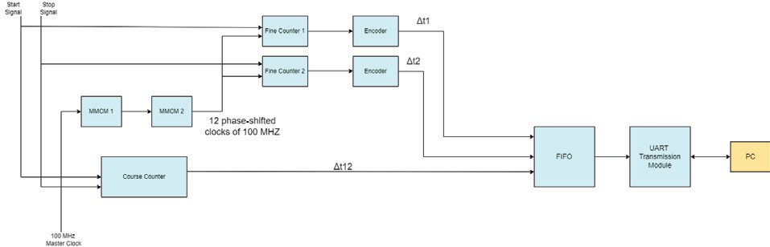
Fig. 1. Block Diagram

The observatory sends the start and stop pulses to the FPGA. Start and clock pulse are fed into fine counter module 1, while stop and clock pulse are fed into fine counter module 2. The time intervals Δt1 and Δt2 are output by the fine counter. The interval here between start and stop pulse edges and the clock’s next positive edge in picoseconds. The coarse counter module receives the start, stop, and clock pulses as inputs. This returns the Δtc time interval, which is the period of 10 nanoseconds between start and stop pulses. This final output is transmitted to the User/PC by using the UART module. The final count is calculated as follows :
ΔT = Δtc + Δt1 - Δt2
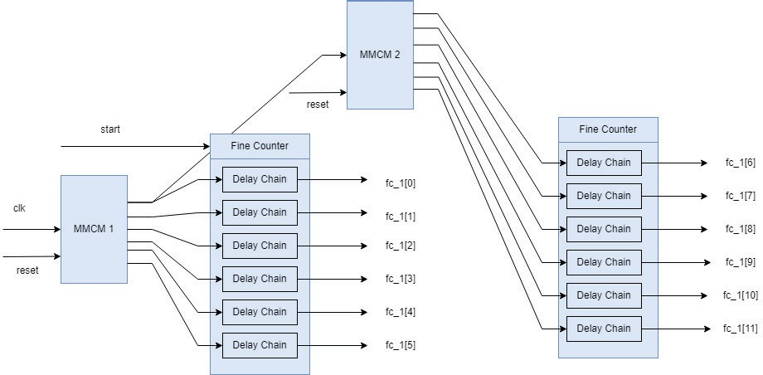
Fig. 2. MMCM Module

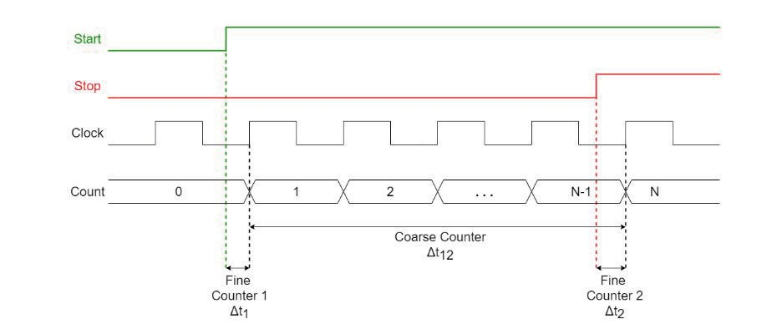
To a entered input clock, MMCM creates several clocks with specified frequency and phase relationships.Each clock network may receive up to two source clocks and seven outgoing clocks. So therefore, we have included two MMCM to get 12 phase shifted clocks.
In this system, the fine counter is implemented with the help of two Mixed-Mode Clock Manager (MMCM) module of the FPGA. The clock of 100 MHz is given as input to first MMCM which gives six equally phase shifted 100 MHz clocks as output.Then the first output clock (clkout1) of first MMCM is given input to the second MMCM which in-turn generates six output clocks of 100 MHz. So total of 12, 100 MHz clocks are generated using 2 MMCM modules.These 12 phase shifted 100 MHz clock latch the start and stop signal to 12-bit thermometer code. The 12-bit value obtained from

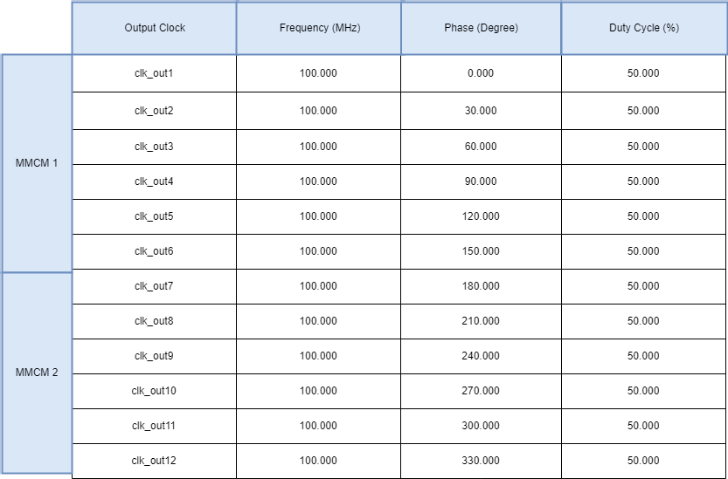

Fig. 3. Output clock of 2 MMCM

this is used to calculate the fine measurement. Figure 3 shows the clocks generated by the MMCM module for use in the fine counter. Since the time period of the 100 MHz clock is 10000 picoseconds, the resolution of the fine counter is 10000 picoseconds ÷ 12 = 833.333 picoseconds. Figure 4 depicts the simulation flow used in the experiment.
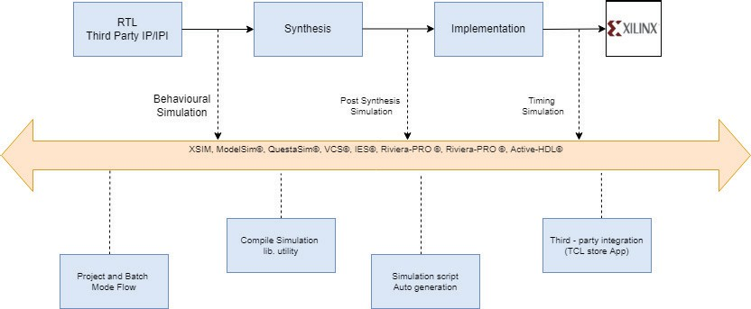
Fig. 4. Simulation Flow

- Proposed System
Our proposed system is a hybrid counter that measures time using the Nutt interpolation approach. An FPGA board will be used to create the circuit (Nexys A7 FPGA). Finally, the UART protocol will be used to communicate in this system.
The nutt interpolation method is used to create the hybrid counter. The key benefit is that it can use the coarse counter to measure long ranges and the fine counter to achieve resolution finer than the clock cycle period.

Fig. 5. Timing Diagram

Figure 5 illustrates how the measurement interval ΔT is broken into three periods. The coarse counter checks one long interval, Δt12, in real - time basis; the two additional short intervals, Δt1 and Δt2 (at the onset and end of the period ΔT), are monitored by a high resolution TDC, i.e. the fine counter. The interval between both the rising edge of the STOP/START signal and next rising edge of the clock is recorded by the fine counter.
  - Course Counter: The coarse measurement in this project was done with a 100 MHz clock. As a result, the coarse counter measures time in 10 nanoseconds increments. Because the fine counter cannot measure lengthy timing intervals, this is a key component. The coarse counter is a simple counter that counts the FPGA clock to measure time intervals.
  - Fine Counter: The fine counter is used to calculate time intervals in the picosecond range. Because the internal clock frequency of the FPGA is 100 MHz, direct counting at a picosecond interval is impossible. The fine counter is
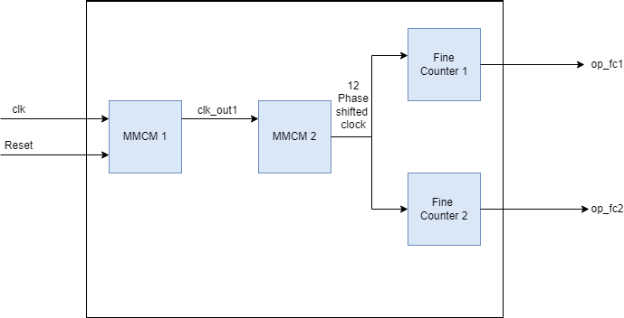
Fig. 6. Fine Counter

implemented in this system using the FPGA’s Mixed-Mode Clock Manager (MMCM) module. A clock of 100 MHz is fed into the first MMCM, which outputs six equally phase shifted 100 MHz clocks, and clkout1, the first output clock of MMCM 1, is fed into MMCM 2, which outputs six equally phase shifted 100 MHz clocks. As a result, a total of 12, 100 MHz clocks with equivalent phase shifts are formed. The start and stop signals are latches to 12-bit thermometer code by these 12 phase shifted 100 MHz clocks. The fine measurement is calculated using the 12-bit value acquired from this.
  - Delay Chain: The delay chain is made up of 3 flip flops, where first flip flop is used for latching and the next 2 flip flops are used to create the delay. Here the latching happens on the clkout1, which is the first MMCM output clock. The first MMCM outputs are delayed on the positive edge of the clk100 MHz, whereas the second MMCM outputs are delayed negative edge.
- DESIGN
Figure 7 describes the setup of the top module hybrid counter. It shows the layout of various components which in turn helps to interpret the processing of signals and generation of output.
Figure 8 Depicts how the system interacts with the external environment. In this figure, there are two actors, the astronomi-cal observatory and the user. The end user here may be another receiving end of the same observatory.The observatory detects

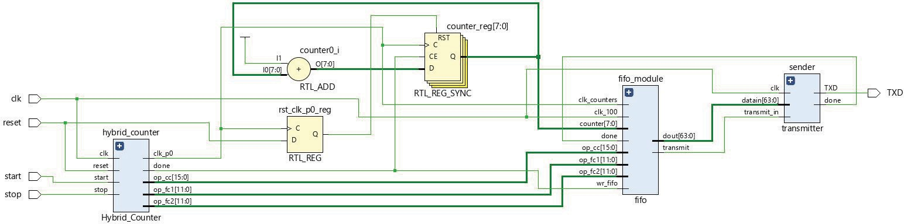

Fig. 7. Schematic Diagram of Top module Hybrid Counter
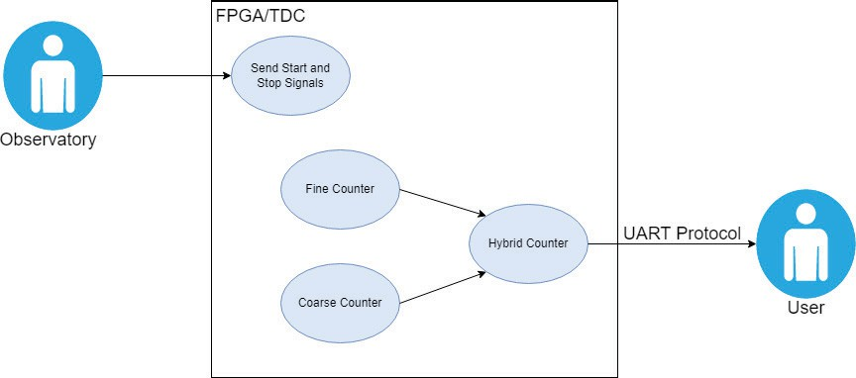

Fig. 8. Use Case Diagram

the light rays using optical sensors and passes the start and stop pulses to the TDC system. The TDC system is fabricated on the FPGA and uses a hybrid counter which is a combination of the coarse and fine counter to measure and output the final time interval. This result is read by the end user.
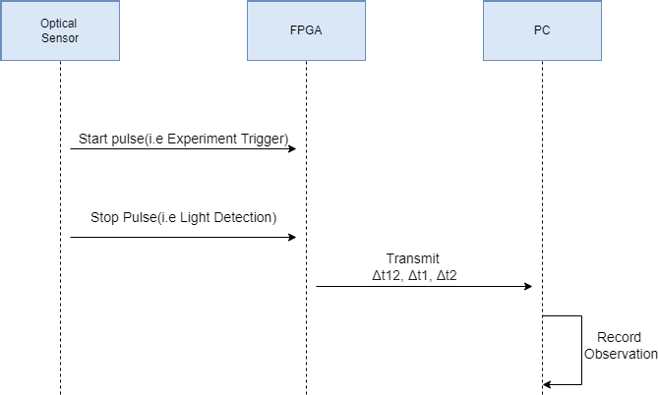
Fig. 9. Sequence Diagram

FFigure 9 depicts the Sequence Diagram, which illustrates object communication in chronological order. It is used to express the series of messages delivered and received between the entities expected to undertake out the instances function-ality. The start pulse is triggered when the experiment begins, and the end pulse is triggered when light is detected by the optical sensors. These two serve as input to the FPGA where the TDC counts the time interval between the two. The FPGA divides the time interval into 3 parts and generates 3 counts (Δtc, Δt1 and Δt2). The values are repeatedly generated and stored accordingly.
- Results And Discussions
Here, figure 10 shows schematic diagram of the 12 bit counter and figure 11 shows the timing diagram of 12 bit counter. clk100 MHz is the master clock input provided, and the fc[11:0] is the fine counter total. clkout0 to clkout11 are the 12 phase shifted clocks of 100 MHz frequency.These phase shifted clock are provided through the MMMCM module of

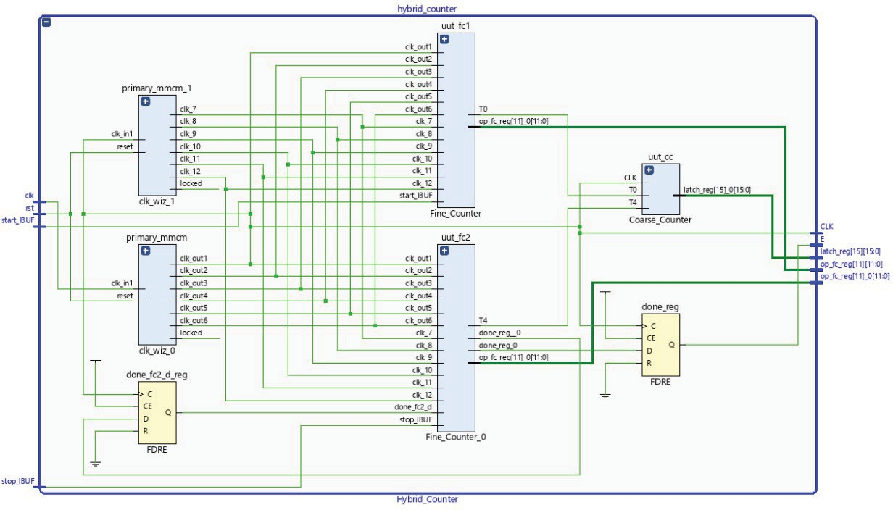

Fig. 10. Schematic Diagram of Hybrid Counter
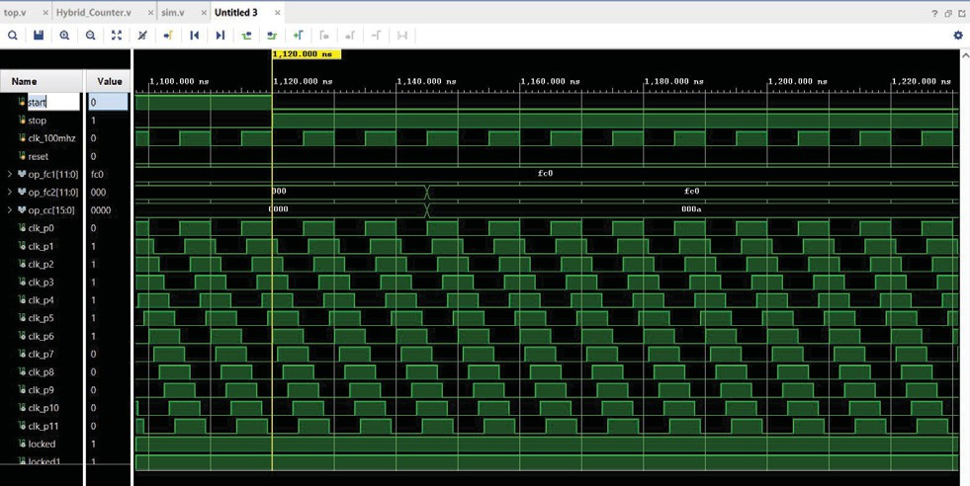

Fig. 11. Timing Diagram of 12-Phase Hybrid Counter

the Vivado Design Suite. We are using 2 MMCM to get an output of 12 bit
We could generate the required simulation by using this method. The reason to use 100MHz clock is to reduce jitter and internal timing calculations which may cause delays in the TDC

- Conclusion

The examination of various methodologies and equipment used to implement coarse counters, fine counters, and time-to-digital converters is described in this research. The benefits of TDCs based on FPGAs are underlined and described. Thus this paper covers all the details regarding the cascaded MMCM setup and the successful simulation hybrid counter. Our goal of achieving the 12 phase hybrid counter simulation is achieved. The experiment can be further extended to design a customized hybrid counter to achieve a better precision.

Acknowledgment

We’d want to show our appreciation to our project super-visor Mr. Irfan Mirza (TIFR) and Dr. Raghunandan Shukla who have guided us throughout this project. We also wish to acknowledge the help provided by the TIFR team and the technical staff at the Fr. C. Rodrigues Institute of Technology’s Computer Engineering Department.
References
- A. Balla, M. Beretta, P. Ciambrone, M. Gatta, F. Gonnella, L. Iafolla,M. Mascolo, R. Messi, D. Moricciani, and D. Riondino, “Low resource fpga-based time to digital converter,” 06 2012.
- T. Sui, Z. Zhao, S. Xie, Q. Huang, J. Xu, and Q. Peng, “Pico-tdc: a novel fpga-based tdc with 2.2ps rms timing resolution,” in 2017 IEEE Nuclear Science Symposium and Medical Imaging Conference (NSS/MIC), pp. 1–3, 2017.
- C. U gur, G. Korcyl, J. Michel, M. Penschuk, and M. Traxler, “264 channel tdc platform applying 65 channel high precision Measure-ment”, vol. 89, 03 2016.
- E. Bayer, P. Zipf, and M. Traxler, “A multichannel high-resolution (¡5 ps rms between two channels) time-to-digital converter (tdc) implemented in a field programmable gate array (fpga),” in 2011 IEEE Nuclear Science Symposium Conference Record, pp. 876–879, 2011.
- D. Chaberski, “Time-to-digital-converter based on multiple-tappeddelay-line,” Measurement, vol. 89, 03 2016.
- Y.-Q. Chen, L.-Y. Meng, and X.-G. Lin, “A coarse-fine time-to-digital converter,” ITM Web of Conferences, vol. 11, p. 08006, 01 2017.
- Foudil Dadouche, Timothe´ Turko, Wilfried Uhring, Imane Malass, Norbert Dumas, Jean-Pierre Le Normand, ”New Design-methodology of High-performance TDC on a Low Cost FPGA Targets.”Sensors Transducers, Vol. 193, Issue 10, October 2015, pp. 123-134
- Jiajun Zheng, Ping Cao, Di Jiang, Qi An, ”Low-Cost FPGA TDC With High Resolution and Density” IEEE Transactions on Nuclear Science ( Volume: 64, Issue: 6, June 2017)
- Jinhong Wang, Shubin Liu, Qi Shen, Hao Li, Qi An, ”A fully fledged TDC implemented in field-programmable-gate-arrays” 2009 16th IEEE-NPSS Real Time Conference
- Jinyuan Wu (Fenni National Accelerator Laboratory, Batavia, IL, USA)”Several Key Issues on Implementing Delay Line Based TDCs Using FPGAs” IEEE Transactions on Nuclear Science ( Volume: 57, Issue: 3, June 2010)

